Subjective Alignment Assessment Report

1. Welcome
This report shows how your work role, environment, goals, and personal style are currently interacting.
It is not a personality test or diagnosis. It is designed to help you understand where things feel aligned, where friction exists, and what may need attention.

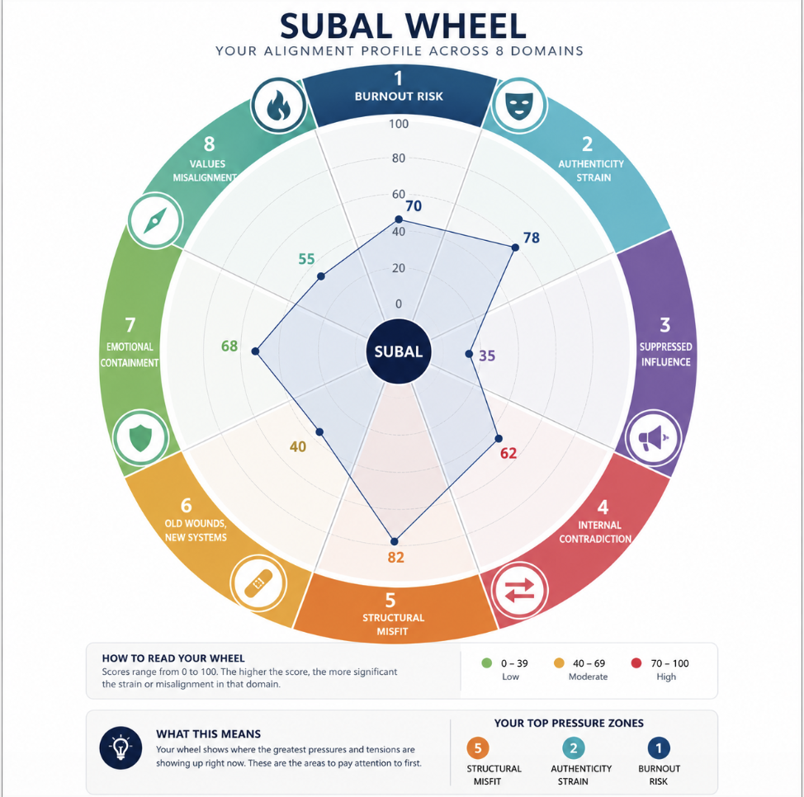

2. Your Overall Alignment Snapshot

Overall Alignment Level
Low / Moderate / High

Main Pattern
A short paragraph summarising the person’s overall result.
Example:
You appear to be operating in a role where your capacity, insight, and ambition are present, but the environment may not fully support how you work best. This creates strain between what you can contribute and what the system allows you to express.

3. Your Top 3 Areas of Strain
These are the strongest patterns identified in your results.

1. [Highest Flag Name]
Level: Low / Moderate / High
What this means:
Short plain-language explanation.

2. [Second Flag Name]
Level: Low / Moderate / High
What this means:
Short plain-language explanation.

3. [Third Flag Name]
Level: Low / Moderate / High
What this means:
Short plain-language explanation.

4. Full Results Summary
Area | Level | What it reflects
Burnout Risk | Low / Moderate / High | Demand versus available energy
Authenticity Strain | Low / Moderate / High | Pressure to adapt or perform
Suppressed Influence | Low / Moderate / High | Gap between insight and impact
Internal Contradiction | Low / Moderate / High | Competing internal drivers
Structural Misfit | Low / Moderate / High | Fit between person, role, and system
Old Wounds, New Systems | Low / Moderate / High | Past experiences shaping present reactions
Emotional Containment | Low / Moderate / High | Capacity to hold and regulate pressure
Values Misalignment | Low / Moderate / High | Fit between work and personal meaning

5. What Your Results Suggest
A short narrative section explaining how the main flags interact.
Example:
Your results suggest that the strongest tension is not simply workload, but the combination of high responsibility, limited influence, and a need to adapt yourself to the environment. This means the strain may not be solved only by rest. It may require better fit, clearer authority, or a role that allows more authentic contribution.

6. Recommended Focus Areas
Based on your results, these are the (# depending on scores) areas most worth reflecting on.

Focus Area 1: [Example: Restore Energy]
Why this matters:
Brief explanation.

Focus Area 2: [Example: Increase Influence]
Why this matters:
Brief explanation.

Focus Area 3: [Example: Reduce Authenticity Strain]
Why this matters:
Brief explanation.

7. Suggested Next Steps
These are reflective, non-prescriptive next steps.
- Review the top 3 areas of strain.
- Identify which result feels most accurate.
- Identify which result feels uncomfortable or surprising.
- Consider whether the issue is mainly personal, relational, structural, or organisational.
- Decide what one small shift would improve alignment in the next month.

8. Closing Reflection
Alignment is not fixed. It changes as your role, goals, environment, and life circumstances change.
This report gives you a snapshot of your current professional system. Its purpose is to help you see the pattern more clearly, so that future decisions can be made with greater awareness.

